**IST 659 Lab 7**

VIEWS

1. Views: create views based on the following requirements

a) interviews_summary: for all the candidates, find their interviews and the

corresponding interviewers. This view should show the candidate ID, candidate

name, interview ID, interviewer ID, and interviewer name.

*/

CREATE VIEW interviews_summary AS

SELECT C.CandidateId, C.CFName, C.CLName, I.InterviewID, IR.InterviewerId

FROM CANDIDATE C

INNER JOIN INTERVIEW I ON C.CandidateId=I.CandidateId

INNER JOIN INTERVIEWER IR ON I.InterviewerId=IR.InterviewerId

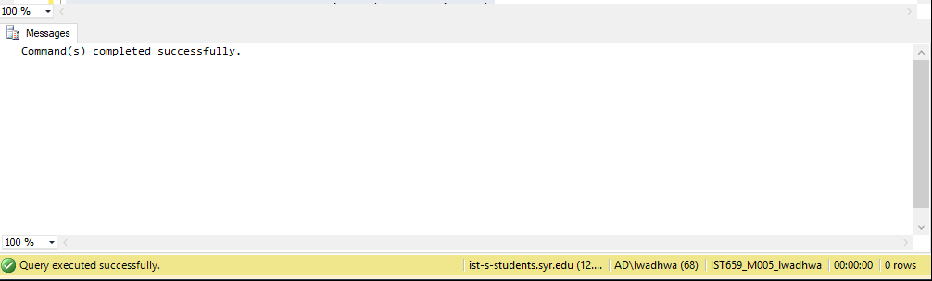

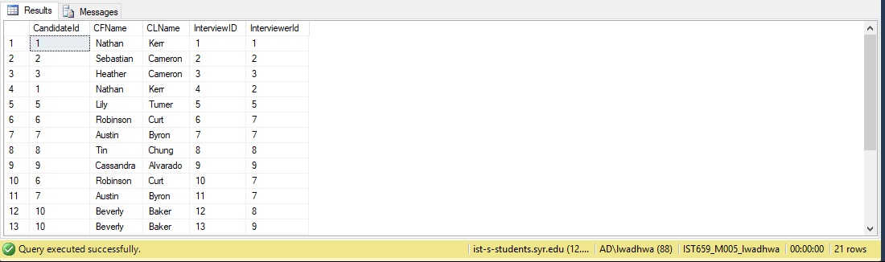

/*position_summary: find the total number of positions available for each company in

the second half of 2013 (Jul, Aug, Sep, Oct, Nov, Dec).*/

CREATE VIEW position_summary AS

SELECT companyID, COUNT(POSITIONID) as "Count of position" FROM POSITION WHERE POSITIONID IN (SELECT DISTINCT PositionID FROM INTERVIEW

WHERE InterviewDate BETWEEN '06-01-2013' AND '12-31-2013')

GROUP BY CompanyID

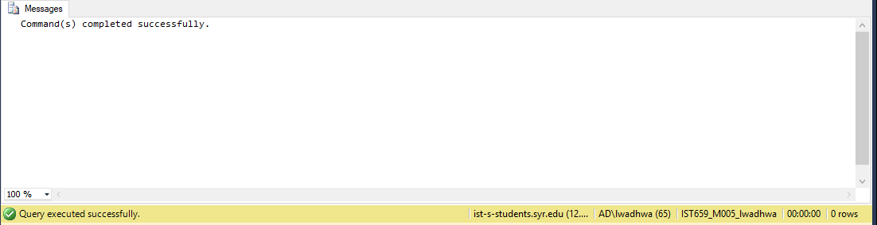

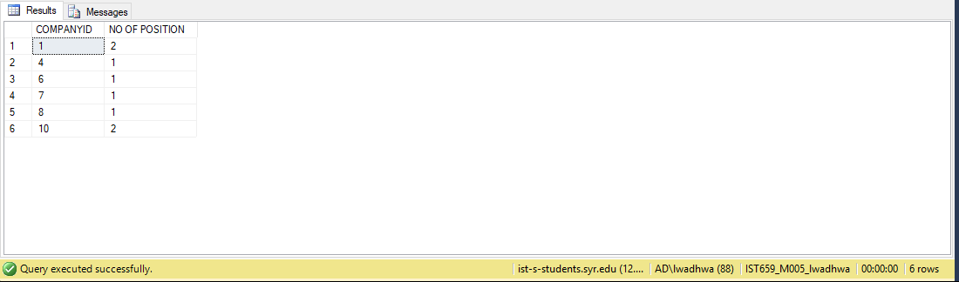

/*maximum_candidate_interview_summary: find the candidate who had the largest

number of interviews.*

CREATE VIEW maximum_candidate_interview_summary AS

SELECT CandidateId, COUNT(INTERVIEWID) AS 'COUNT OF INTERVIEWS'

FROM INTERVIEW

GROUP BY CandidateId

HAVING

count(InterviewID)=

(SELECT MAX(A.CNT)

FROM (SELECT COUNT(CandidateId) AS CNT FROM INTERVIEW

GROUP BY (CandidateId)) AS A)

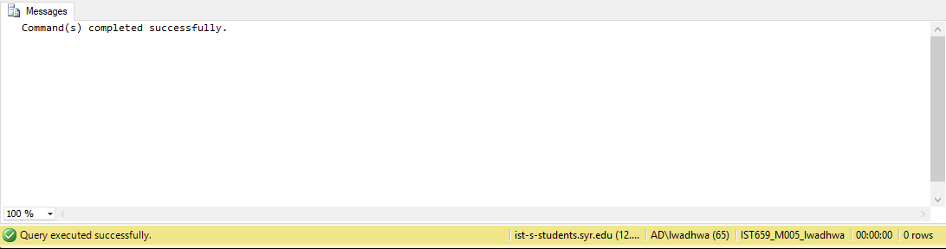

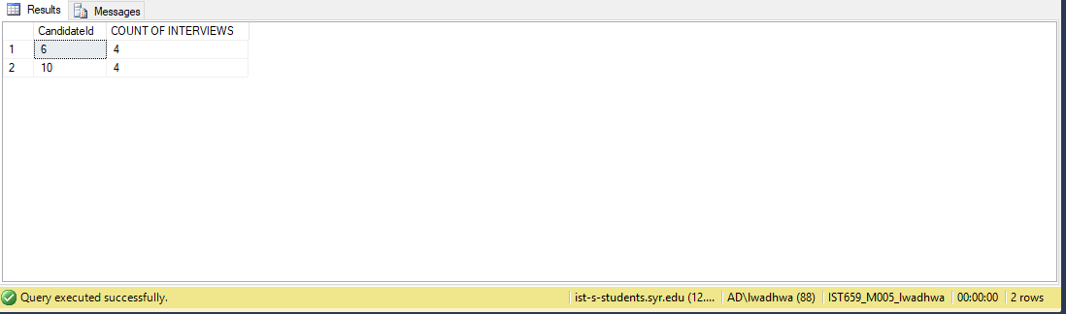

/*minimum_interviewer_prescription_summary: find the interviewer who had the

lowest number of interviews.*/

CREATE VIEW minimum_interviewer_prescription_summary AS

SELECT CandidateId, COUNT(INTERVIEWID) AS 'COUNT OF INTERVIEWS'

FROM INTERVIEW

GROUP BY CandidateId

HAVING

count(InterviewID)=

(SELECT MIN(A.CNT)

FROM (SELECT COUNT(CandidateId) AS CNT FROM INTERVIEW

GROUP BY (CandidateId)) AS A)

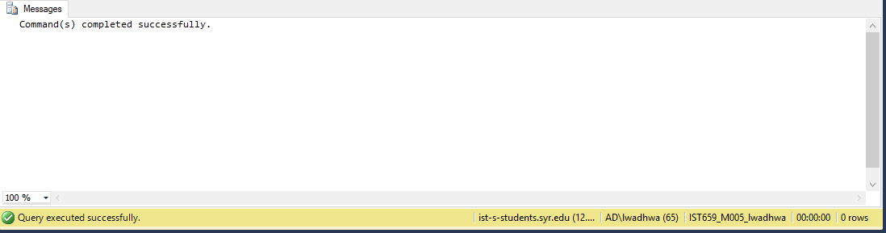

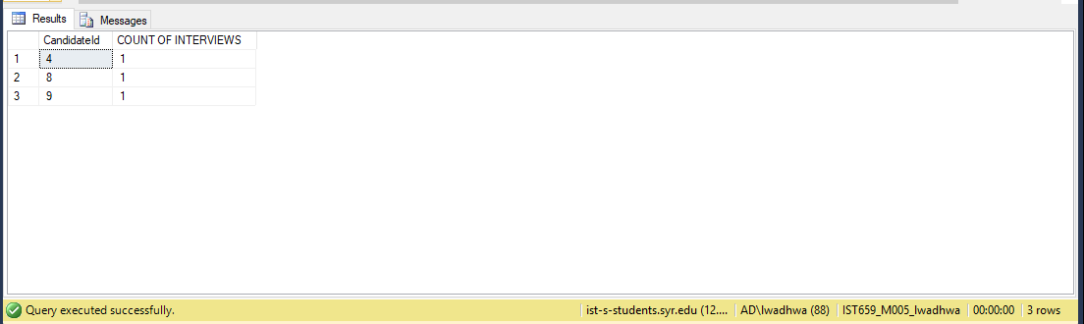

/* position_interview_summary: find the position for which the largest number of

interviews were conducted.:

CREATE VIEW position_interview_summary AS

SELECT POSITIONID, COUNT(INTERVIEWID) AS 'COUNT OF INTERVIEWS'

FROM INTERVIEW

GROUP BY PositionID

HAVING

count(InterviewID)=

(SELECT MAX(A.CNT)

FROM (SELECT COUNT(POSITIONId) AS CNT FROM INTERVIEW

GROUP BY (PositionID)) AS A)



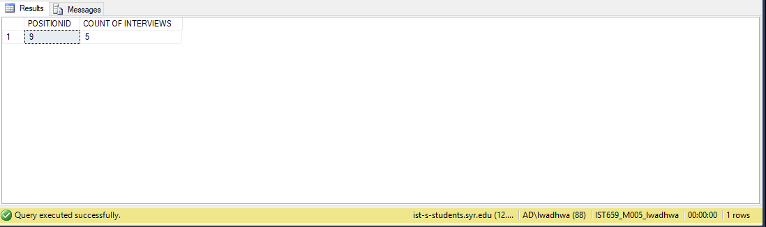

TRANSACTIONS

SET IMPLICIT_TRANSACTIONS ON;

SET XACT_ABORT ON;

BEGIN TRANSACTION

-- STEP 1: ADD MULTIPLE INSERTS IN ONE TRANSACTION

INSERT INTO CANDIDATE VAlUES(11, 'Shah', 'Kantilal', '315-525-2552', 193, 'Lancaster Ave', 'Syracuse','NY', 13210, 'Database and

Development', 'Database Administration', NULL)

INSERT INTO POSITION VALUES(13, 'Database Developer', 'Entry', 'yes', 6)

INSERT INTO INTERVIEW VALUES(22, 1, '2013-11-08 00:00:00.000', 11, 8, 13)

-- STEP 2: SEE THE RESULTS

SELECT * FROM CANDIDATE

SELECT * FROM INTERVIEW

SELECT * FROM POSITION

-- STEP3: ROLLBACK

ROLLBACK

-- STEP 4: SEE THE RESULTS

SELECT * FROM CANDIDATE

SELECT * FROM INTERVIEW

SELECT * FROM POSITION

RESULTS BEFORE ROLLBACK:

CANDIDATE TABLE

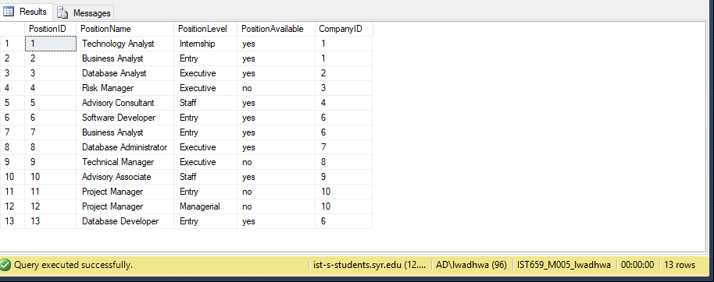

INTERVIEW TABLE

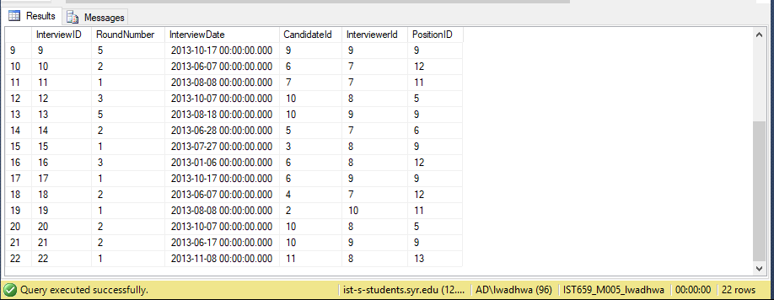

POSITION TABLE

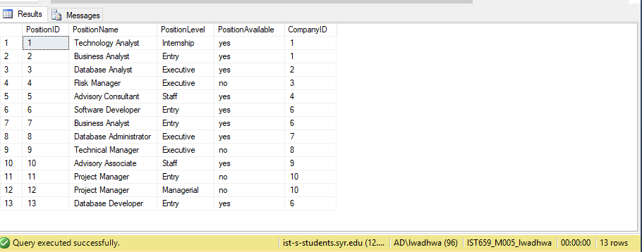

RESULTS POST ROLLBACK

CANDIDATE TABLE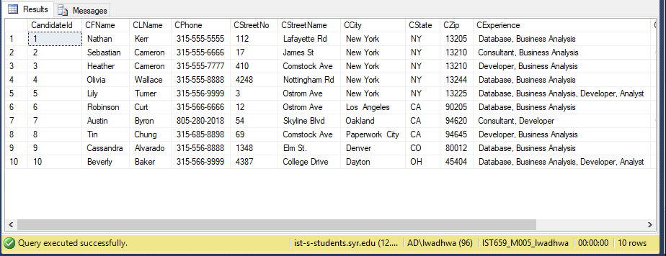

INTERVIEW TABLE

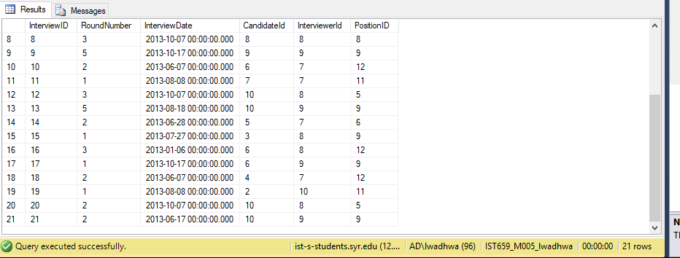

POSITION TABLE

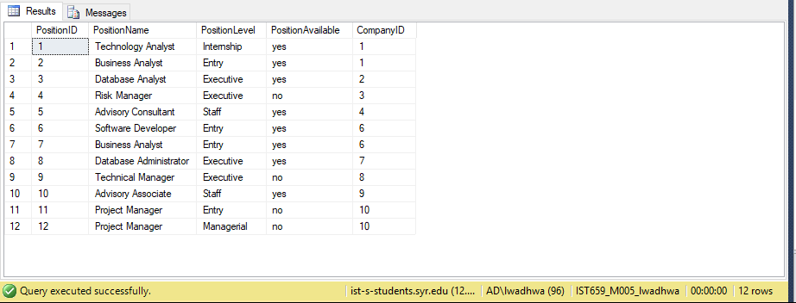

--BEGIN THE TRANSACTION

BEGIN TRANSACTION

-- STEP 1: ADD MULTIPLE INSERTS IN ONE TRANSACTION

INSERT INTO COMPANY VALUES(11, 'Apple', '400-000-1212', 'www.apple.com', 1, 'Infinite Loop', 'Cupertino', 'CA', 95014)

INSERT INTO POSITION VALUES(14, 'Program Analyst', 'Staff', 'yes', 11)

INSERT INTO INTERVIEW VALUES(23, 1, '2013-11-01 00:00:00.000', 2, 10, 14)

INSERT INTO INTERVIEW VALUES(24, 1, '2013-11-01 00:00:00.000', 5, 10, 14)

INSERT INTO INTERVIEW VALUES(25, 1, '2013-11-01 00:00:00.000', 8, 10, 14)

-- STEP 2: SEE THE RESULTS

SELECT * FROM COMPANY

SELECT * FROM POSITION

SELECT * FROM INTERVIEW

-- STEP3: COMMIT

COMMIT TRANSACTION;

-- STEP 4: SEE THE RESULTS

SELECT * FROM COMPANY

SELECT * FROM POSITION

SELECT * FROM INTERVIEW

RESULTS BEFORE COMMIT TRANSACTION

COMPANY TABLE

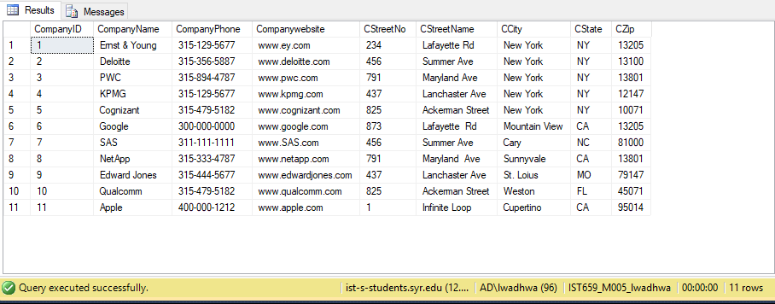

POSITION TABLE

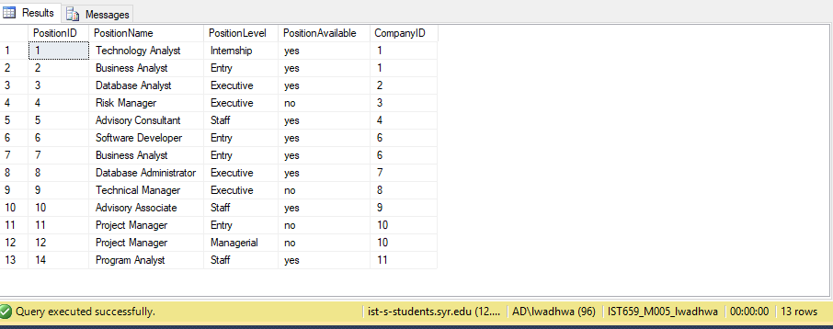

INTERVIEW TABLE

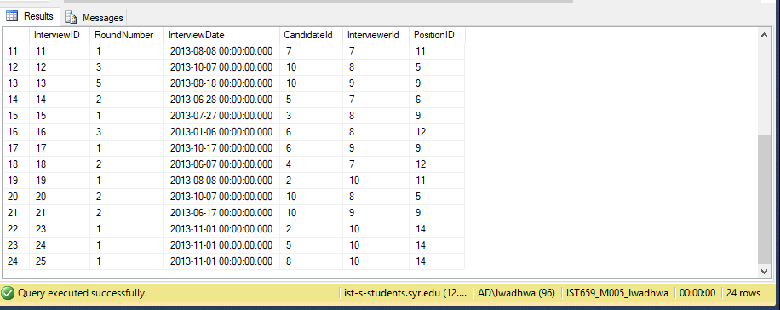

RESULTS AFTER COMMIT

COMPANY TABLE

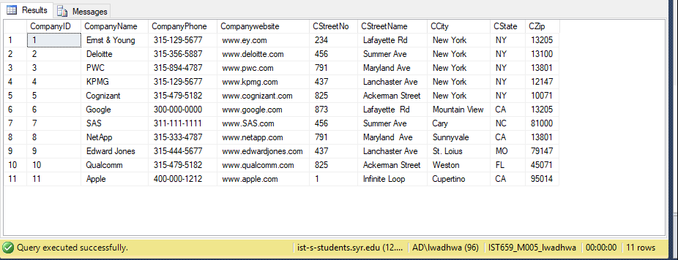

POSITION TABLE

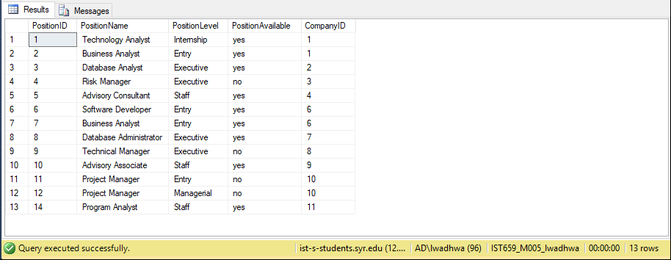

INTERVIEW TABLE

